\



Lab 2: Writing a Logic App

Hands-on Lab

Released:

Terms of Use

© 2018 Microsoft Corporation. All rights reserved.

Information in this document, including URL and other Internet Web site references, is subject to change without notice. Unless otherwise noted, the companies, organizations, products, domain names, e-mail addresses, logos, people, places, and events depicted herein are fictitious, and no association with any real company, organization, product, domain name, e-mail address, logo, person, place, or event is intended or should be inferred. Complying with all applicable copyright laws is the responsibility of the user. Without limiting the rights under copyright, no part of this document may be reproduced, stored in or introduced into a retrieval system, or transmitted in any form or by any means (electronic, mechanical, photocopying, recording, or otherwise), or for any purpose, without the express written permission of Microsoft Corporation.

For more information, see **Microsoft Copyright Permissions** at [**http://www.microsoft.com/permission**](http://www.microsoft.com/permission)

Microsoft may have patents, patent applications, trademarks, copyrights, or other intellectual property rights covering subject matter in this document. Except as expressly provided in any written license agreement from Microsoft, the furnishing of this document does not give you any license to these patents, trademarks, copyrights, or other intellectual property.

The Microsoft company name and Microsoft products mentioned herein may be either registered trademarks or trademarks of Microsoft Corporation in the United States and/or other countries. The names of actual companies and products mentioned herein may be the trademarks of their respective owners.

**This document reflects current views and assumptions as of the date of development and is subject to change.  Actual and future results and trends may differ materially from any forward-looking statements.  Microsoft assumes no responsibility for errors or omissions in the materials.**

**THIS DOCUMENT IS FOR INFORMATIONAL AND TRAINING PURPOSES ONLY AND IS PROVIDED "AS IS" WITHOUT WARRANTY OF ANY KIND, WHETHER EXPRESS OR IMPLIED, INCLUDING BUT NOT LIMITED TO THE IMPLIED WARRANTIES OF MERCHANTABILITY, FITNESS FOR A PARTICULAR PURPOSE, AND NON-INFRINGEMENT.**

Table of Contents

Lab Overview 1

Exercise 1: Create Logic App to receive Dynamics update 2

Exercise 2: Update Cosmos DB with Account document 10

# Lab Overview

###### Abstract

In this lab, we will be working with a Logic App and the connector to Dynamics CRM. We will be capturing customer account changes in Dynamics CRM and replicating those to a Cosmos DB. You can think of the Cosmos DB as a cache of the CRM account data that will be displayed on the eShopOnWeb eCommerce website. In addition to the replication there will be an email to a manager to receive input to define the Category field for the Customer record before it is passed to the Cosmos DB.

###### Learning Objectives

After completing the exercises in this lab, you will be able to:

* Create a Logic App to receive changes from the Dynamics CRM system.
* Use the connector to initiate an email to a user with multiple selections.
* Use the Cosmos DB connector and simple formatting of text in the Logic App.

**Estimated time to complete this lab: *30* minutes**

# Exercise : Create Logic App to receive Dynamics update

#### Scenario

In this exercise, you will be creating the Logic App to receive an update from Dynamics CRM when an account entity is updated.

After completing this exercise, you will understand:

* How to create a Logic App in the portal designer.
* How to use the connector to Dynamics 365.

#### Prerequisites:

To complete this lab, you should have a basic understanding of the Azure Portal and Dynamics 365

#### Install and configure:

You will need:

* A desktop computer (host) running Windows 10
* An active Azure subscription (MSDN credits will suffice)
* An active Internet connection
* Office 365 email account

#### Creating Dynamics CRM Instance

If you have completed this from the prerequisites then you can skip section and just login to your CRM portal at https://<your domain name>.crm.dynamics.com/. Start with the **Creating the Logic App and Connect to Dynamics** section.

1. Create a unique instance for yourself for the lab. The Logic App will react to a change for every Account entity in the CRM instance. Go to <https://signup.microsoft.com/Signup?OfferId=bd569279-37f5-4f5c-99d0-425873bb9a4b&dl=DYN365_ENTERPRISE_PLAN1&Culture=en-us&Country=us&ali=1>
2. Fill in the form with your information to create an instance. You can use your Microsoft email address for the **Business Email Address**. Once complete click **Next**.   
   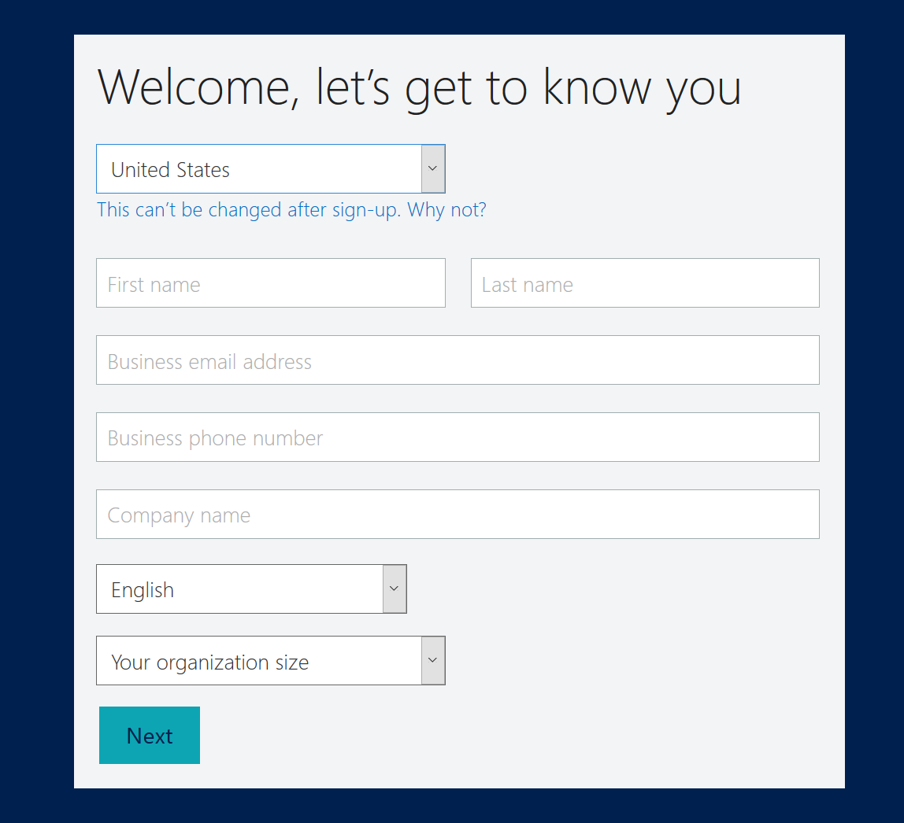
3. Create a **username** and new **company name** to create an account and a **password** then click **Create my account**.  
   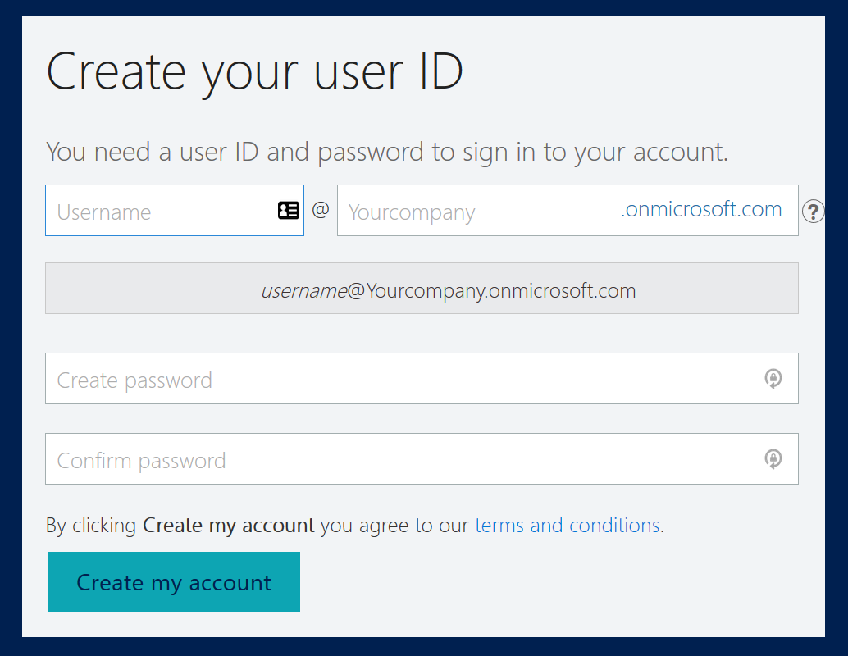
4. Next, you’ll need to validate that you are not a robot.  
   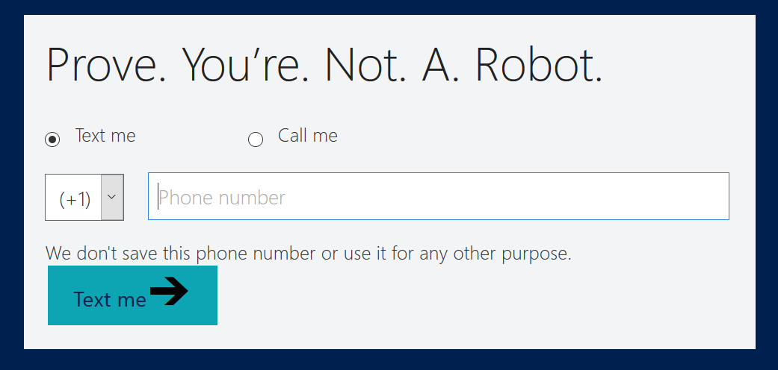
5. Save the info, specifically the sign in URL and the userID you created. Then click the **Set up** button.  
   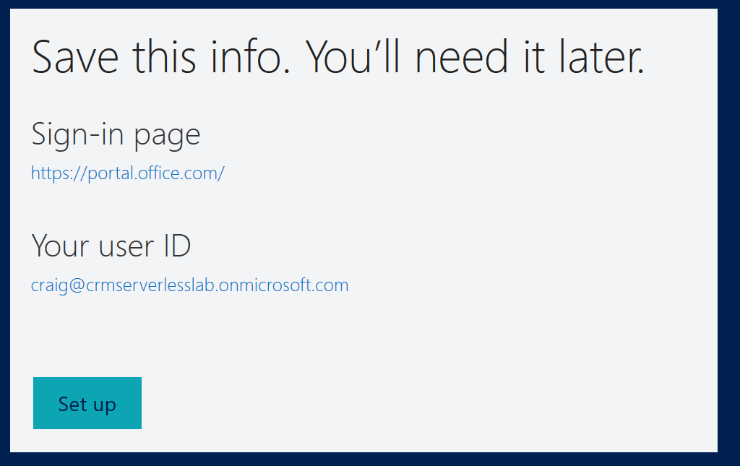
6. Next, select the **Customer service** box which will unselect the Sales box and then click **Complete Setup**.  
   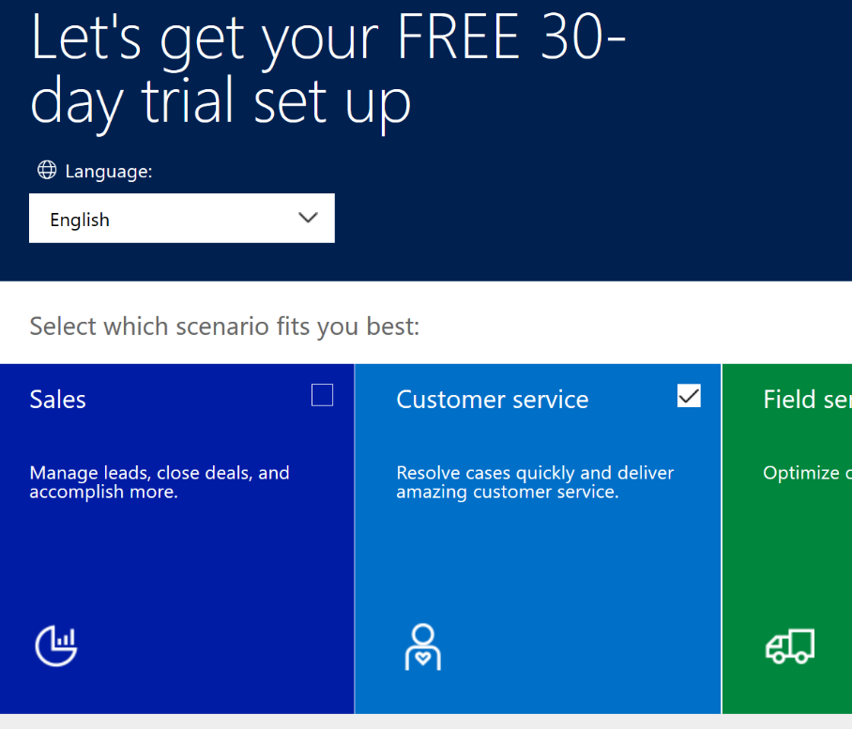
7. It will take about a minute to finish provisioning the CRM instance.
8. Leave the window open, so you can come back and edit accounts later in the lab.

#### Creating the Logic App and Connect to Dynamics

1. Navigate to the Azure Management portal, <http://portal.azure.com>.
2. Select **+ New**, then type **logic app** into the search box on top. Select **Logic App** from the results.

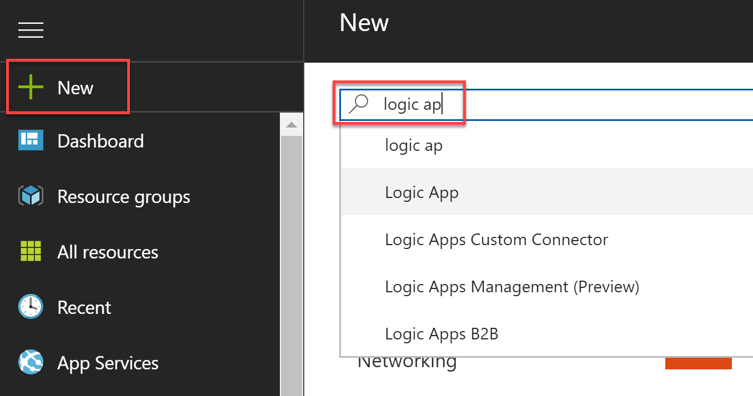

1. Select the **Create** button on the Logic App overview blade.
2. On the Create Logic App blade, specify the following configuration options:
   1. **Name**: unique value for the App name (ensure the green check mark appears).
   2. Specify the Resource Group **ServerlessLabs**, could be new or existing but you’ll want to keep everything in the same resource group for ease of management.
   3. Select the same **location** as your Resource Group.

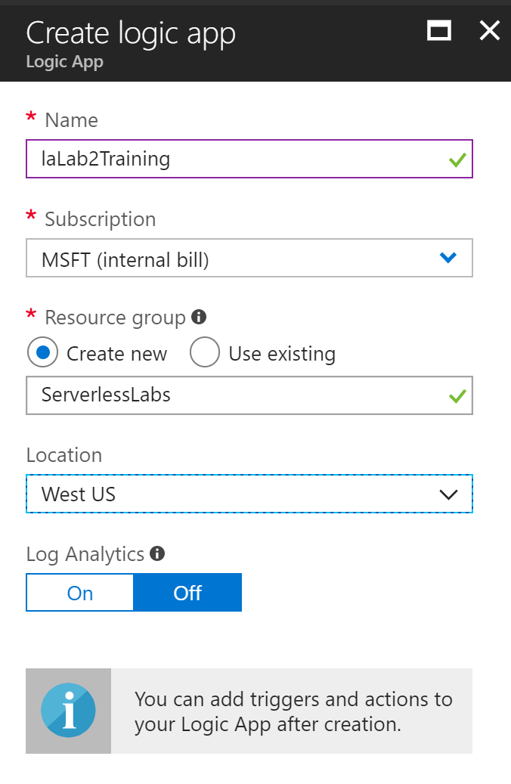

1. Open the Logic App once it has been provisioned. Click either the **Edit** button on the **Logic App Designer** link to open the designer or the **Logic App Designer** link on the left-hand side under the Development Tools heading.  
   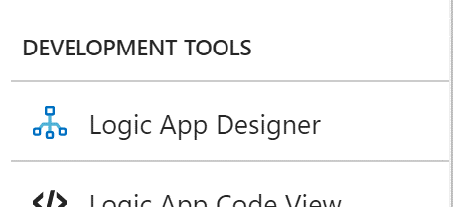
2. Since we will not be starting with a common connector or a template, scroll down and click the box that says **Blank Logic App**.
3. Then use the search box and enter, **dynamics** and select **Dynamics 365 – When a record is updated**.

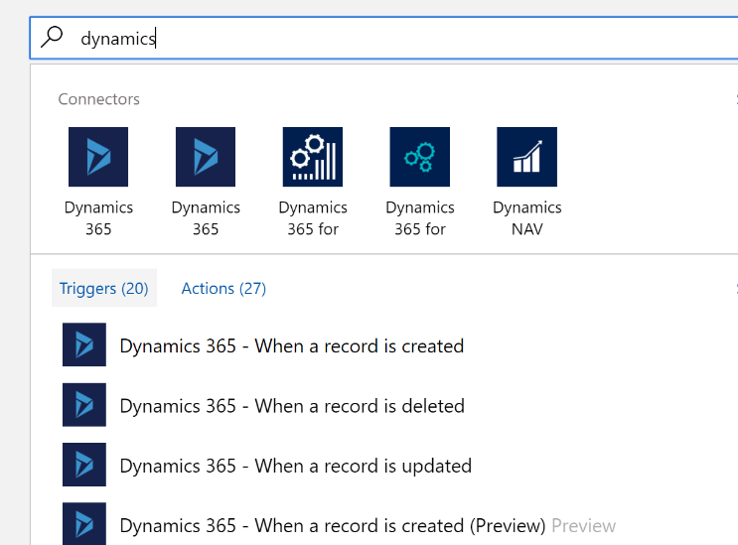

1. Next, you’ll be asked to sign in to Dynamics 365. Use the credentials that you used to create Dynamics 365 instance with in the last section (or during the prerequisites if you did it previously.)
2. Configure the connection. Pick the **Organization Name**, which will be the tenant you created in the last section. Select **Accounts** for the **Entity Name** and change the **Interval** to **1** Minute for a quicker response during testing.  
   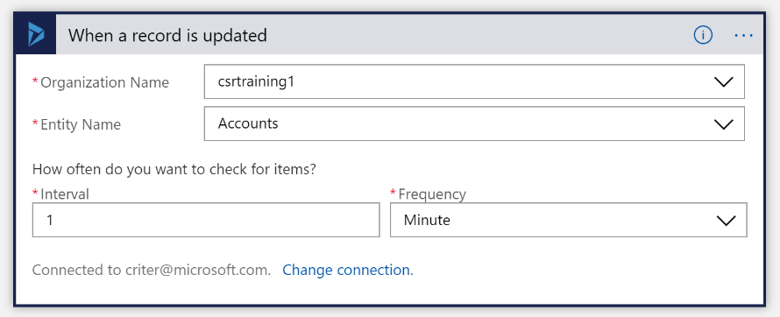
3. Click **Next Step** and search for **Email** connector and select **Office 365 Outlook – Send approval email**.
4. Sign in to your Office 365 Outlook email account.
5. Click on the ellipsis on the upper right corner of the action box and select **Rename**. Change the title to **Send Customer Category email**.  
   
   1. Now, update the rest of the settings.  
      **To** – set this to your address so emails will come to your mailbox for testing purposes. In a real application this would likely be built to be dynamic from the data in some way.  
      **Subject** – set this to **Set Customer Category** and add the Account Name field.  
      **User Options** – set this to the strings **Category A, Category B, Category C**. This could be dynamic from the data as well, but for this simple case we will use these static values.  
      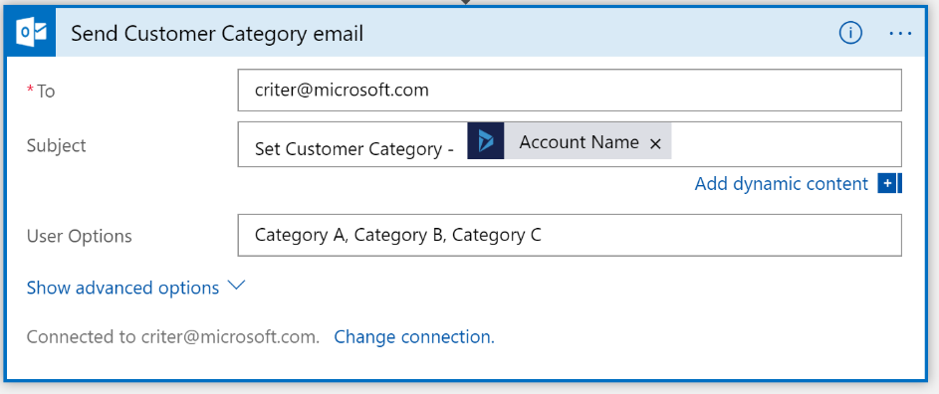
6. Test that everything is working. You should be able to save the Logic App and Run it. Go to your **Dynamics 365** instance and navigate to **Accounts** by clicking the **down arrow** next to **Service** and then click **Accounts**.  
   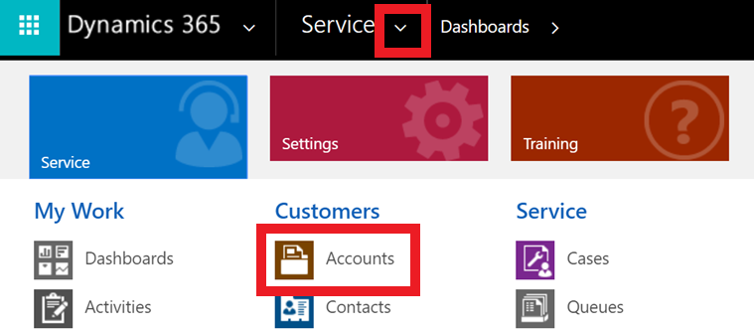
7. Then click on any of the account names to open the account detail form. You can then edit the name field and then click on the save icon in the lower right hand corner of the screen.  
   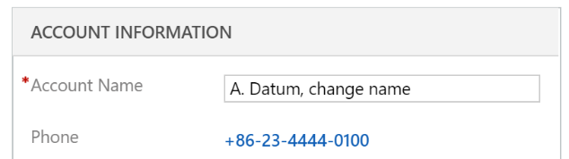 
8. You should receive an email that you need to click a link on and you should see this in your Logic App window.  
   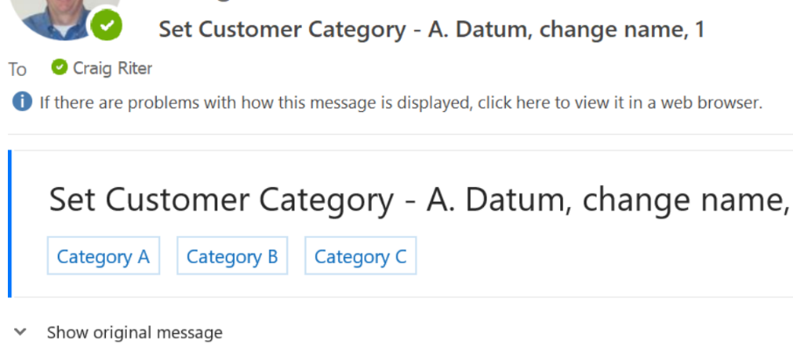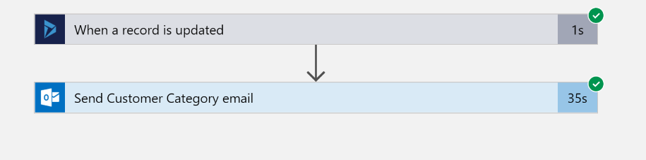

# Exercise : Update Cosmos DB with Account document

#### Scenario

In this exercise, you will be using the account information from the Dynamics CRM update and the information from the email selection to build a JSON document that will be inserted/updated to a Cosmos DB.

After completing this exercise, you will understand:

* How to compose a basic JSON document in a Logic App
* How to connect to Cosmos DB and upsert a document

#### Prerequisites:

To complete this lab, you should have a basic understanding of the Azure Portal, CRM and JSON.

You can use Azure Storage Explorer to review the contents of the Cosmos DB. Download Azure Storage Explorer from <https://azure.microsoft.com/en-us/features/storage-explorer/>

#### Install and configure:

You will need:

* A desktop computer (host) running Windows 10
* An active Azure subscription (MSDN credits will suffice)
* An active Internet connection

#### Create the Cosmos DB

1. Open a new browser window. It will take a few minutes to provision the DB and you can move on to the next step while this is happening.
2. Navigate to the Azure Management Portal (<http://portal.azure.com>) and search for: **Cosmos DB** and click on the row.  
   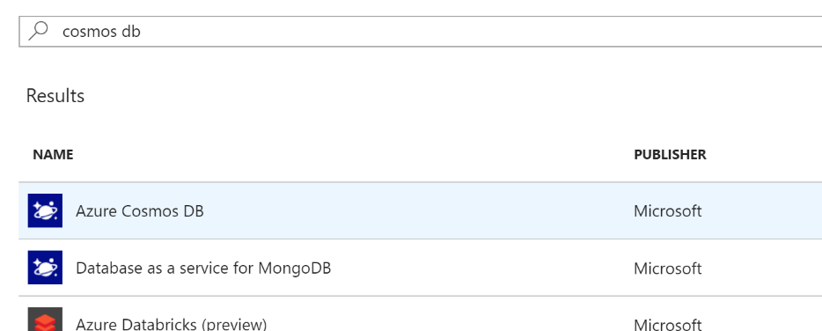
3. Click the **Create** button. With the blade open, enter the value to create it. The ID should be unique. **API** should be **SQL** since we aren’t trying to be compatible with other protocols. Use an existing **Resource Group** if you are trying to keep your resources together. Choose which ever **Location** is appropriate for you. Then click **Create**.  
   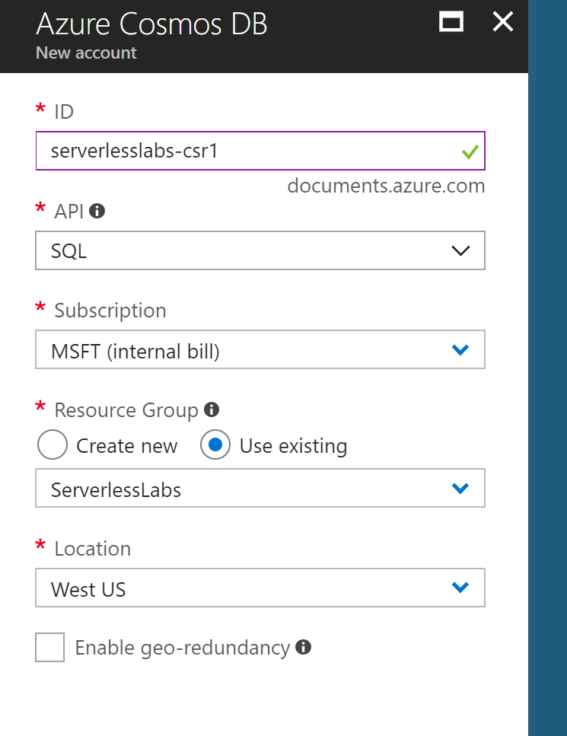
4. While that is creating, move on to the next section, **Completing the Logic App**. We will finish up with the configuration of the Cosmos DB. There will be a step in that section that will direct you back to here.
5. Click **Go to resource** from the Notifications window.  
   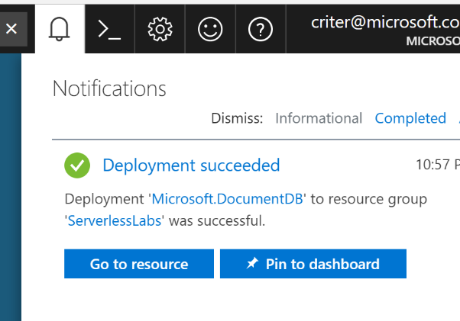
6. Next, click the **Overview** link and then the **Add Collection** button at the top. Use the values in the screenshot to create the database and collection.  
   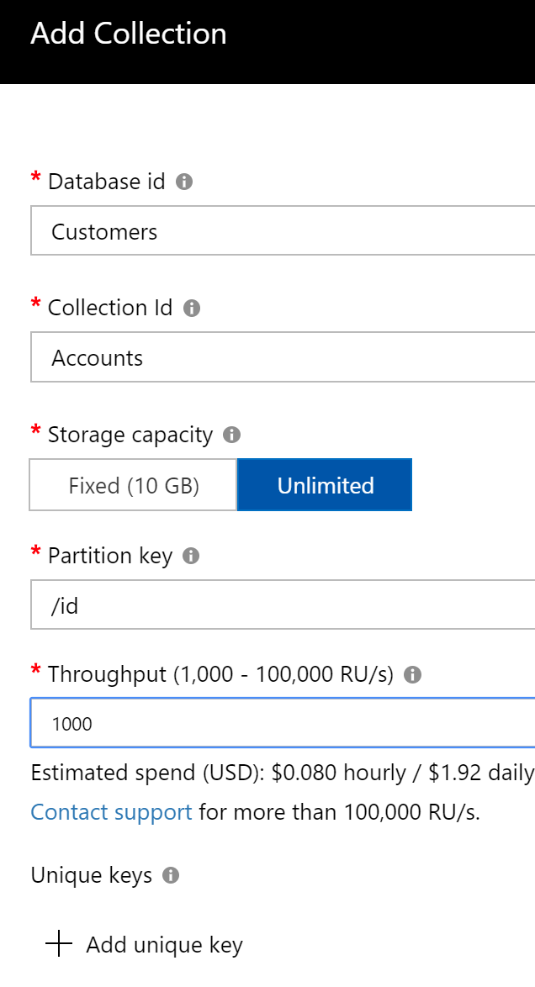
7. Go back to Step 6 in the next Section.

#### Completing the Logic App

1. Navigate back to the Logic App Designer used in the Exercise 1.
2. Click **New Step** after the Send email action and click **Add an action**.
3. Search for **Compose** and select **Data Operations – Compose**.

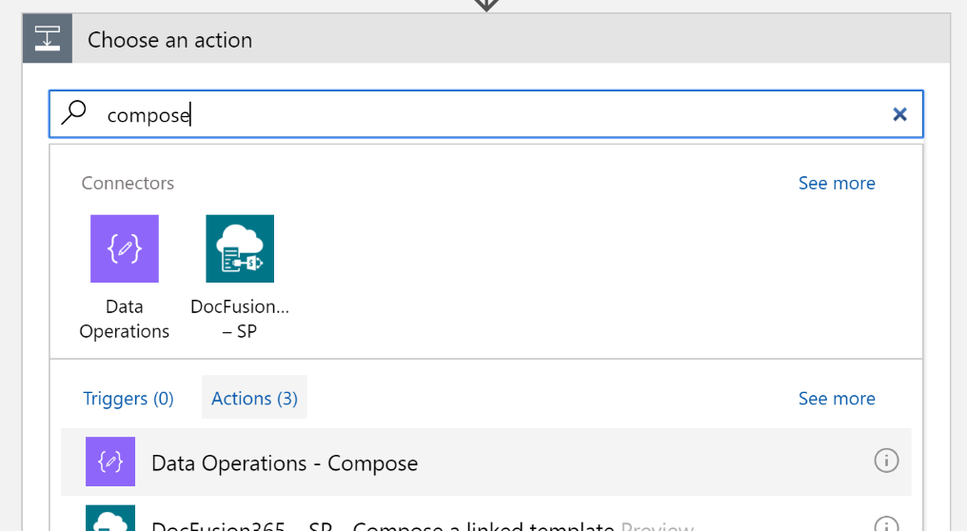

1. In the **Inputs** box, start to build a JSON string which will be the document inserted into the Cosmos DB. Using the **Rename** function off the ellipsis, change the title to **Create Account JSON Document**. Modify the **Inputs** to create the document as shown in the screenshot.

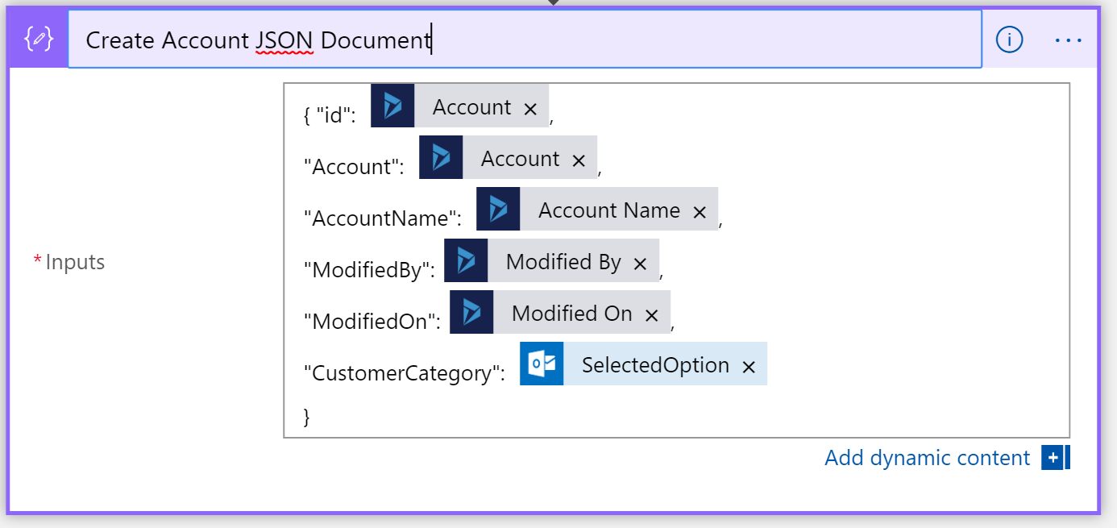

1. By now, the Cosmos DB should be provisioned. **Go back to Step 5** in the previous section to pick up where you left off.
2. Create the next step using the **New Step** button. Select **Add an action** and search forC **Cosmos**. Select **Azure Cosmos DB – Create or update document**.

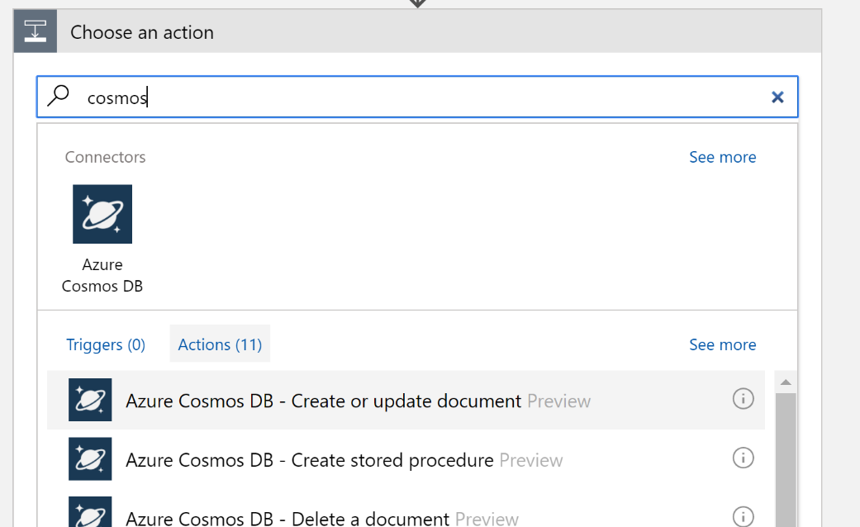

1. Pick the Cosmos DB you created in the previous section, give it a connection name, and click **Create**.  
   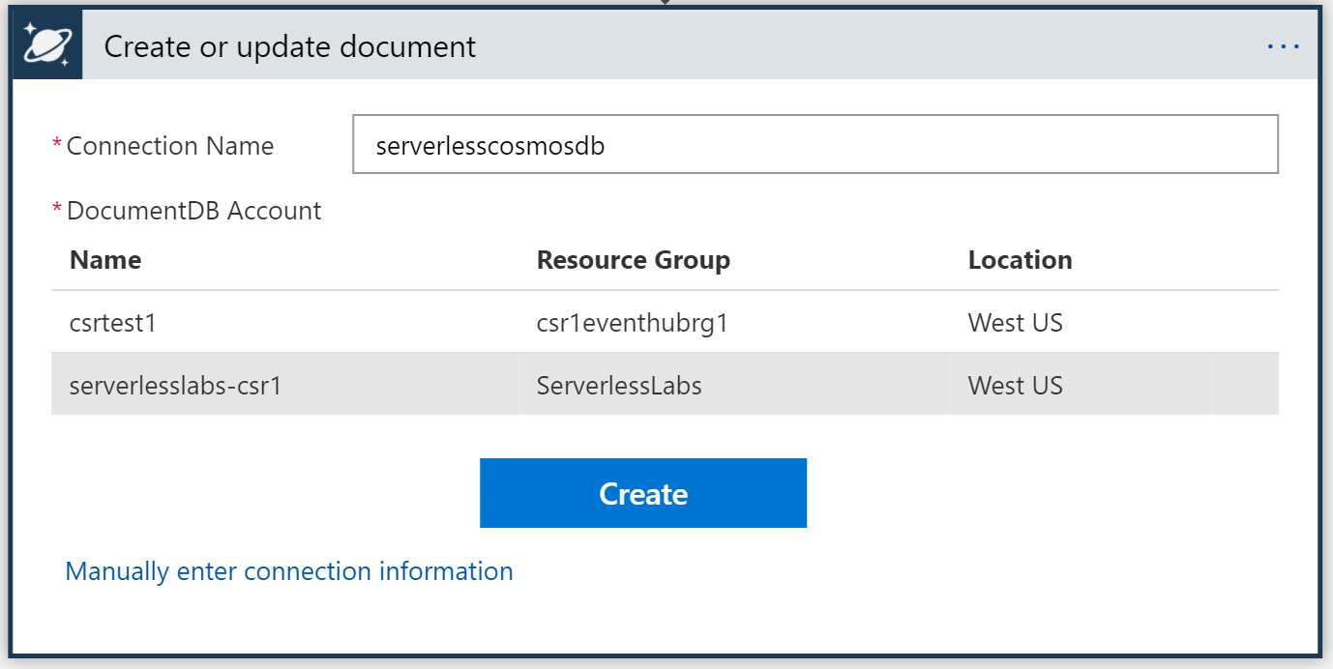
2. Fill in the value for the connector as shown below.  
   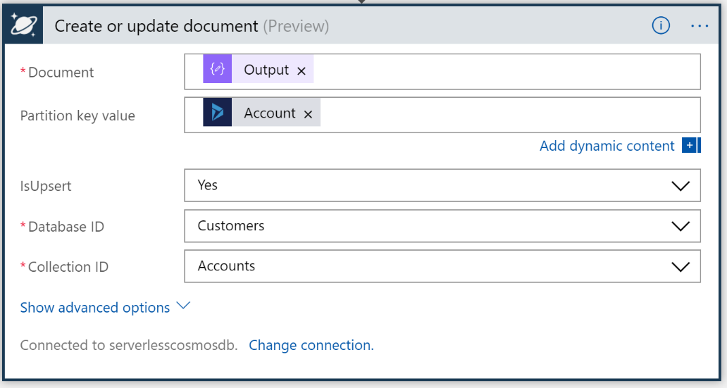
3. At this point, you should be able to save the Logic App and test it again. To test, will have you edit an account in CRM by just changing an account name. This will trigger an email, when you receive the email, click one of the Category selections in the email mail. Finally, it should upsert that account record into the Cosmos DB.
4. You can then look at the new entry in Cosmos DB for the document. You can look at the Cosmos DB using the Azure Storage Explorer. Just sign into your account using Storage Explorer and expand the node with the Cosmos DB accounts.  
   